Healthy Living for Your Communication Channels

Share tools, resources, and healthy recipes and articles with your employees and members of your community. General message, images, and links for newsletters are included.

November- American Diabetes Month
🚨 Over 38 million Americans are living with diabetes. The American Diabetes Association® is on a mission to end this epidemic. Join us this #AmericanDiabetesMonth by getting involved and spreading awareness. Learn how you can get involved at diabetes.org/ADM. #WeFight 💪

Suggested Visual:

The Good Fight campaign video

🔍 November is both #AmericanDiabetesMonth and #DiabeticEyeDiseaseMonth—a crucial time to highlight the importance of eye health for those living with diabetes. Regular eye exams can catch issues early and safeguard your vision. 👀 Make your #eyehealth a priority, not just this month, but always. Find helpful eye-related resources from the American Diabetes Association® at bit.ly/3zv6qS0.

Suggested Visual:

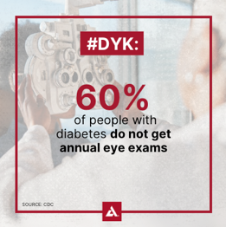

World Diabetes Day: November 14
On #WorldDiabetesDay, let's come together 🤝 to support the 537 million people with diabetes and educate those at risk. Learn more about how you can show your support at diabetes.org/ADM. 🌍💙 #AmericanDiabetesMonth #WeFight
Suggested Visual:

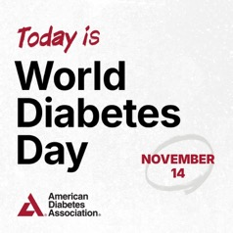

December
Giving Tuesday: December 2
I fight for a future without diabetes because no family should have to see their loved ones struggle with this disease. That’s why I’m proud to support the American Diabetes Association® this #GivingTuesday. Will you join the fight to end diabetes? Donate today at diabetes.org. 💙 🥊 #WeFight
Suggested Visual:



✨ The holiday season has arrived! Did you know the National Diabetes Prevention Program can help you discover nourishing holiday foods that support your health and provide resources for making informed decisions? 🥦 📚 See if you qualify today at dpp.diabetes.org/DiabetesPrevention. #PreventDiabetes #DiabetesPreventionProgram

Suggested Visual:

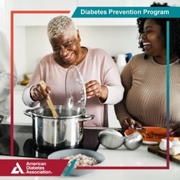

🌟🛫 Don't let diabetes hold you back! Check out travel tips from the American Diabetes Association® and stay safe on the go. Learn more at bit.ly/4f7ER0I. #DiabetesTravelTips #HolidayTravel

Suggested Visual:

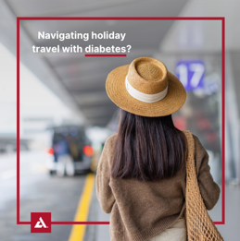

Diabetes is personal for me. Nearly 1 in 2 Americans is affected by #diabetes or #prediabetes. We're fighting to end this epidemic! 💪 Join me by making a donation at diabetes.org. Together, #WeFight. 👊

Suggested Visual:

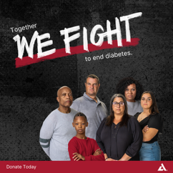

January
Are you one of the many people who look forward to the “January reset” to start or restart a healthy habit? You’re not alone! Check out these tips from the American Diabetes Association® for success and find more information to help you on your journey at bit.ly/3BW1mrz. 🌟💪 #JanuaryReset #HealthyHabits

Suggested Visual:

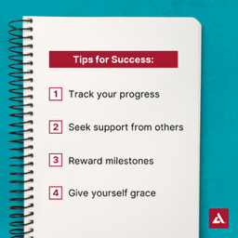

As we navigate the challenges of living with #diabetes, it’s important to remember our mental health is just as crucial as our physical health. 🧠 🚶‍♀️Take the first step today by exploring the American Diabetes Association®’s mental health resources and connecting with a professional who can provide the support you need. Learn more at diabetes.org/MentalHealth. #MentalHealthMatters #MentalHealth

Suggested Visual:



February
#DYK adults with diabetes are twice as likely to have a heart disease or stroke than those without it. Take control this #AmericanHeartMonth! ❤️ Track your blood glucose (blood sugar), blood pressure, and weight. Alert your health care team of any changes. For resources and information about the symptoms of heart disease, visit bit.ly/41953EB. #HeartHealth

Suggested Visual:



Super Bowl Sunday: February 8
Game day alert! 🚨🏈 Need delicious diabetes-friendly appetizers that support your blood glucose (blood sugar)? The American Diabetes Association® has you covered! Check out Diabetes Food Hub® at diabetesfoodhub.org.

Suggested Visual:



#ICYMI: Catch up on the American Diabetes Association®’s Ask the Experts events, focusing on obesity care conversations, available treatments, and more to support your journey. Watch the recordings now at bit.ly/4knkT5q.

Suggested Visual:
Ask the Experts Obesity Playlist

March
This #NationalNutritionMonth, make it a priority to discover how nutrition can support your health goals. Learn more from the American Diabetes Association® at bit.ly/3CUvDYo. ✨
Suggested Visual:

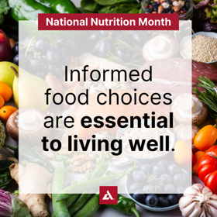

#DYK approximately 1 in 3 adults with diabetes has chronic kidney disease (CKD)? March is #NationalKidneyMonth, a time to shine a light on this vital issue! 🕵️‍♀️ Let's learn about the link between diabetes and kidney disease and find empowering ways to put your health first at diabetes.org/Kidney.

Suggested Visual:

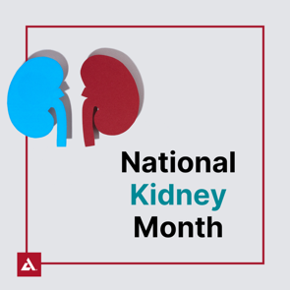

If you're facing challenges with obesity, consulting your doctor is a crucial step in creating a personalized treatment plan. The American Diabetes Association® has developed a resource, the Obesity Care Self-Management Decision Making guide, to empower you with the tools and information you need to better manage your health. Check it out at bit.ly/4i5Yis0.

Suggested Visual:

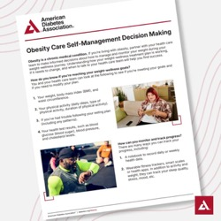

🎉 The 2026 Tour de Cure® season is in full swing with events happening across the country! 🚴‍♂️ 🚴‍♀️ Join us and the American Diabetes Association® at an event near you or learn how you can participate virtually at diabetes.org/Tour. 🌟 #ADATour2026
Suggested Visual:
Or a picture of yourself at a Tour de Cure® event


April
This #NationalMinorityHealthMonth, take action! American Indian/Alaskan Native, non-Hispanic Black, Hispanic, and Asian American adults are at a higher risk for type 2 diabetes. Take the American Diabetes Association®’s free 60-second risk test and share it with your loved ones. Learn your risk now at diabetes.org/RiskTest. #NMHM25 #KnowYourRisk
Suggested Visual:

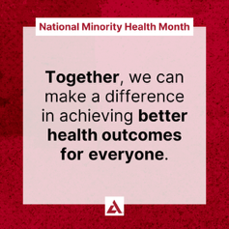

Black Maternal Health Week: April 11-16, 2026
This #BlackMaternalHealthWeek, let’s empower women to prioritize their health during pregnancy. Black women in the U.S. face much higher risks of maternal mortality and complications, especially those living with diabetes. We can make a difference together! Download the American Diabetes Association®’s gestational diabetes (GDM) resources at bit.ly/4292zq0. #BMHW26
Suggested Visual:



National Volunteer Week: April 19-25, 2026
Share your personal story about why you volunteer for the American Diabetes Association® and what it means to you. Be sure to include #NVW and encourage people to join you as a volunteer at diabetes.org/GetInvolved.
For example:
“I started volunteering for the American Diabetes Association® after seeing the impact diabetes had on my loved ones. It's more than just giving time—it's about being part of a community that's determined to make a difference. Every event, every advocacy effort, brings us one step closer to a world free of diabetes. The smiles, the hope, and the resilience I see inspire me to keep going. It's not just about volunteering, it's about being a catalyst for change. That's what it means to me. Want to join me in the fight to end diabetes? Learn more at diabetes.org/GetInvolved.”
Suggested Visual:
A picture of yourself volunteering at an ADA event

National Tell a Story Day: April 27, 2026
Share your story about diabetes, including why you joined the fight to end diabetes, with the American Diabetes Association® and encourage people to share their story too at diabetes.org/Blog.
For example:
“Living with type 1 diabetes since my late twenties, I've experienced firsthand the daily challenges and triumphs that come with managing this condition. From the initial shock of diagnosis to the endless finger pricks, insulin injections, and constant monitoring, diabetes has been a persistent presence in my life.
I'm not alone in this fight. Each of us has a story to tell—a reason why we want to see an end to this disease. Your story matters and it can inspire others to join us. Please share your personal journey with diabetes at diabetes.org/Blog. Together, with the American Diabetes Association®, we can end diabetes.”
Suggested Visual:
A picture of yourself

May
This #MentalHealthAwarenessMonth, let's not forget that managing diabetes is a journey with both our bodies and minds. Use the American Diabetes Association®’s Mental Health Professional Directory to find a professional near you who can offer the support you need at bit.ly/3E7JGKF. 💪 🧠 ✨ #MentalHealthMatters #MHAM2026
Suggested Visual:
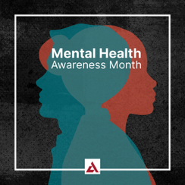

This #HealthyVisionMonth, prioritize your eye health by scheduling a dilated and comprehensive eye exam! 🕶️ 👀 These exams are vital for preventing, detecting, and managing diabetes-related eye disease and vision loss. Discover more tips from the American Diabetes Association® to keep your eyes healthy at bit.ly/3xHxhcO. #EyeHealth #DiabetesAwareness
Suggested Visual:


#DYK gestational diabetes affects as many as 1 in 10 pregnancies in the U.S. every year? This #WomensHealthMonth, I’m standing with the American Diabetes Association® to spread awareness and resources. 💪📚 Learn more about gestational diabetes and find additional women’s health resources at bit.ly/3UDfNH2.
Suggested Visual:


You can take action to prevent type 2 diabetes right now. The National Diabetes Prevention lifestyle change program provides education, practical tools and group support to help you build healthier habits. Sign up today and start moving towards a healthier future. Enroll now at dpp.diabetes.org/DiabetesPrevention. #PreventDiabetes #DiabetesPreventionProgram
Suggested Visual:
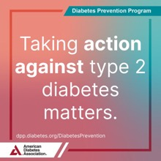

June
This #MensHealthMonth, we’re shining a light on obesity in men with the American Diabetes Association®. Obesity significantly increases the risk of type 2 diabetes and can affect wellbeing. Learn about obesity treatment options and how to work with your health care team to create a plan that meets your needs. Find out more at diabetes.org/Obesity. #MensHealth #MHM
Suggested Visual:
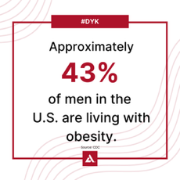

It’s time we work together and face the challenge head on. Advocating for people with obesity is essential. Learn more about how you can join the American Diabetes Association® as an Obesity Advocate today at bit.ly/3xKoEyt.
Suggested Visual:
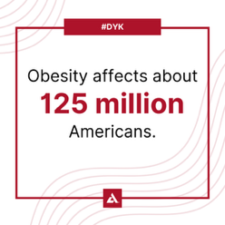

July
In honor of #NationalPicnicMonth, serve this healthy grilled chicken recipe by the American Diabetes Association® at your next picnic. It makes a great substitute for fried chicken or bratwursts. Your guests will appreciate a healthier option and will enjoy this slightly sweet and citrusy dish. This recipe makes 4 servings, view the full recipe at bit.ly/4eDCYtL.
Suggested Visual:
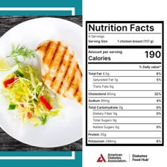

July is National Make a Difference to Children Month! 🎉 The American Diabetes Association® is transforming the lives of countless children with type 1 diabetes every summer through their amazing camp program. 🏕️ Want to learn more? Check out diabetes.org/Camp. #ADACamp2026
Suggested Visual:


👟💙 Step Out® Walk is a chance to raise critical funds to help the American Diabetes Association® fight to end diabetes. Every step and every dollar raised all matter in ending this disease that over 38 million Americans are living with. Find your local walk today at diabetes.org/StepOut. #ADAStepOut2026
Suggested Visual: Or a picture of yourself at a Step Out® event


August
Do you know a child with diabetes? Help them flourish this school year with these must-know tips from the American Diabetes Association®. Explore more resources at diabetes.org/SafeAtSchool. 📚🍎 #SafeAtSchool #BackToSchool
Suggested Visual:
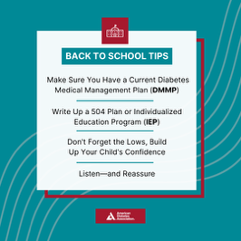

ADA Anniversary: August 27, 2026
I'm proud to stand with the American Diabetes Association® in the fight to end diabetes. Will you join me? Discover how you can make a difference at diabetes.org/GetInvolved. 💙 #WeFight
Suggested Visual:
Picture of yourself or reshare National ADA social posts

Individual Rights Day: August 29, 2026
This #IndividualRightsDay, take a stand for diabetes awareness and advocacy. Join the American Diabetes Association®’s movement to ensure everyone has access to the care they need as we fight to end diabetes. Become a Diabetes Advocate today at diabetes.org/Advocacy. 💙 #WeFight
Suggested Visual:


September
💙 💜 This #SuicidePreventionMonth, remember that you’re not alone—especially if you’re managing diabetes. Find specialized support near you with the American Diabetes Association®’s Mental Health Professional Directory at bit.ly/3E7JGKF. If you need help right now, call 988 anytime. Your mental health matters. #MentalHealthMatters #MentalHealth
Suggested Visual:
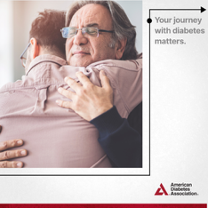

Hispanic Heritage Month: September 15-October 15, 2026
Happy #HispanicHeritageMonth! This month, we celebrate the vibrant culture, achievements, and resilience of Hispanic and Latino communities while shining a light on the impact of diabetes. 💙
Suggested Visual:


Hispanic Heritage Month: September 15-October 15, 2026
In honor of #HispanicHeritageMonth, spice up your mealtime with a delicious low-carb twist on a Mexican favorite—Green Bell Pepper Enchiladas! 🫑 Whether you're a fan of Tex-Mex cuisine or looking to add some excitement to your dinner table, these enchiladas are a diabetes-friendly delight. 🍽️ View the full recipe that makes eight servings at bit.ly/45t6yPH.
Suggested Visual:
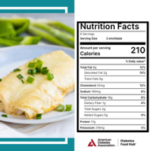

October
World Food Day: October 16
Tight budgets often lead to tough choices between nutritious food and essential medication. Let's raise awareness this #WorldFoodDay and share vital information and resources from the American Diabetes Association® at bit.ly/3VlyJui.
Suggested Visual:


From heart disease to depression, obesity is linked to over 200 health conditions. Educate yourself on the risks and start your journey to better health. Discover more from the American Diabetes Association® at bit.ly/3Y6qmU1.
Suggested Visual:


